Problem: Subtract the product and sum of digits
Problem link: https://leetcode.com/problems/subtract-the-product-and-sum-of-digits-of-an-integer
C source code:
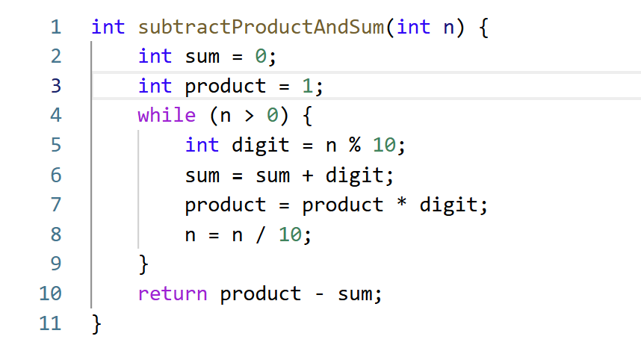
Screenshot of successful submission:


